**DBMS: LAB ASSIGNMENT-3**

**NAME :** Mohammed Abdul Haseeb

**ROLL NO :** 20BCS085

**AIM:** **This particular project was aimed to completely understand, implement and design tables with DBMS software (MySQL is the software used in this assignment) using the knowledge gained from course DATABASE MANAGEMENT SYSTEM (CS310).**

**EXPERIMENT:**

**create database Assignment_3;**

**use Assignment_3;**

**:-Creating database named Assignment_3….**

**create table Assignment_3.Employee(**

**EmployeeID numeric(9) primary key,**

**firstname varchar(10),**

**lastname varchar(20),**

**deptcode char(5),**

**salary numeric(9,2));**

**create table Assignment_3.Department(**

**code char(5) primary key,**

**name varchar(30),**

**manegerID numeric(9),**

**subdeptof char(5));**

**create table Assignment_3.Project(**

**ProjectID char(8) primary key,**

**deptcode char(5),**

**description varchar(200),**

**startdate date,**

**stopdate date,**

**revenue numeric(12,2));**

**create table Assignment_3.Workson(**

**Employee ID numeric(9),**

**Project ID char(8),**

**assigned time numeric(3, 2));**

**:-Creating Employee, Department, Project, Workson tables with primary key.**

**alter table Assignment_3.Employee**

**add foreign key (deptcode)**

**references Department(code);**

**alter table Assignment_3.Department**

**add foreign key (manegerID)**

**references Employee(EmployeeID),**

**add foreign key (subdeptof)**

**references Department(code);**

**:-Adding foreign keys between Employee and Department.**

**alter table Assignment_3.Workson**

**add foreign key (EmployeeID)**

**references Employee(EmployeeID),**

**add foreign key (projectID)**

**references Project(ProjectID);**

**:-Adding foreign keys between Workson and Employees.**

**alter table Assignment_3.Project**

**add foreign key (deptcode)**

**references Department(code);**

**:-Adding foreign keys between Projects and Department.**

**insert into Employee**

**(EmployeeID, firstname, lastname, salary)**

**values**

**(1, 'Keerti', 'vijaykumar', 60000),**

**(2, 'Ritika', 'Patil', 40000),**

**(3, 'Reetu', 'SH', 24500),**

**(4, 'Rohan', 'Pattanshetti', 100000),**

**(5, 'Amin', 'Makandar', 56000),**

**(6, 'Pavan', 'Hugar', 50000),**

**(7, 'Som', 'Bali', 38500),**

**(8, 'Micheal', 'Jackson', 160000);**

**insert into Department**

**(Code, name, manegerID, subdeptof)**

**values**

**('GEM', 'General Management', 1, 'GEM'),**

**('MKT', 'Marketing', 2, 'GEM'),**

**('OPT', 'Operations', 3, 'GEM'),**

**('FIN', 'Finance', 4, 'GEM'),**

**('HRD', 'Human Resource', 5, 'GEM'),**

**('PUR', 'Purchasing', 6, 'GEM'),**

**('PRE', 'Public Relations', 7, 'GEM'),**

**('SAL', 'Sales', 8, 'GEM');**

insert into Project

(ProjectID, deptcode, description, startdate, stopdate, revenue)

values

('H1', 'HRD', 'Policies, procedures, safety rules and other important information design to overcome language and cultural barriers', '2021-10-26', '2022-03-14', 74700),

('M1', 'MKT', 'A study on the factors affecting dealer performance to evolve a strategy for increasing market share', '2022-01-29', '2023-03-29', 50000),

('M2', 'MKT', 'Emergence of Internet Marketing -Origins, Needs, Challenges and Opportunities', '2021-12-05', '2022-11-02', 34500),

('S1', 'SAL', 'IMPACT OF CELEBRITY ENDORSEMENT ON CONSUMER BEHAVIOR AND SALES VOLUME OF AN ORGANIZATION', '2022-02-13', '2023-06-12', 60000),

('S2', 'SAL', 'DIGITAL MARKETING AS A KEY DRIVER OF SALES IMPROVEMENT AMONG SMALL AND MEDIUM SCALE ENTERPRISES', '2021-09-30', '2022-04-07', 55000),

('P1', 'PUR', 'To provide quality services to business joining hands with new and emerging technologies.', '2021-07-16', '2022-09-28', 70000),

('H2', 'HRD', 'A study on identification of non performing dealers and measures to be taken to convert them into performing dealers', '2022-01-01', '2023-06-04', 148500),

('F1', 'FIN', 'Investment awareness in financial asset and preference of financial intermediaries in equities trading', '2021-11-11', '2022-08-22', 750000);

**insert into Workson**

**(EmployeeID, projectid, assignedtime)**

**values**

**(1, 'H1', 1.32),**

**(2, 'M1', 4.55),**

**(3, 'M2', 3.00),**

**(4, 'S1', 2.15),**

**(5, 'S2', 8.22),**

**(6, 'P1', 9.30),**

**(7, 'H2', 6.20),**

**(8, 'F1', 5.45);**

**update Employee**

**set deptcode='GEM' where EmployeeID=1;**

**update Employee**

**set deptcode='MKT' where EmployeeID=2;**

**update Employee**

**set deptcode='OPT' where EmployeeID=3;**

**update Employee**

**set deptcode='FIN' where EmployeeID=4;**

**update Employee**

**set deptcode='HRD' where EmployeeID=5;**

**update Employee**

**set deptcode='PUR' where EmployeeID=6;**

**update Employee**

**set deptcode='PRE' where EmployeeID=7;**

**update Employee**

**set deptcode='SAL' where EmployeeID=8;**

**EXERCISE :**

1. **List the first name and last of all employees.**

**Select firstname, lastname from Employee**

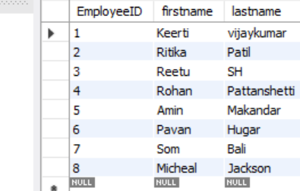

1. **List all attributes of the projects with revenue greater than $40,000.**

**select revenue from Project where revenue>40000;**

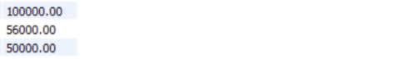

1. **List the department codes of the projects with revenue between $100,000 and $150,000.**

**select revenue from Project where (revenue>100000 and revenue<150000);**

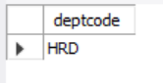

1. **List the project IDs for the projects that started on or before July 1, 2004.**

**select Projectid from Project where startdate <= '2004-07-01';**

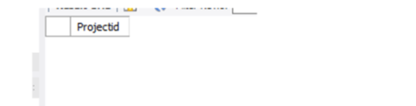

**5.** **List all the department codes assigned to a project. Remove all duplicates.**

**select distinct deptcode from Project;**

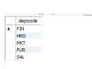

**Result:**

**schema diagram Employee**

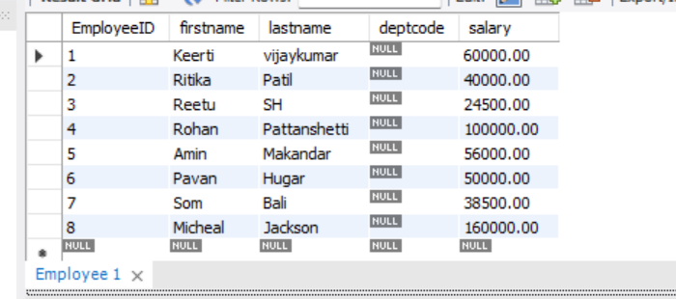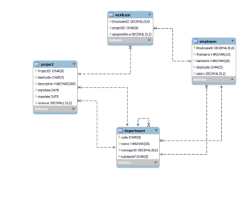 **Department**

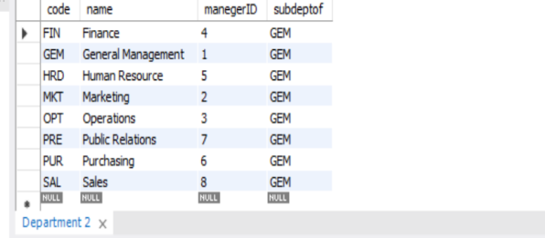

1. **Tables**

**Project**

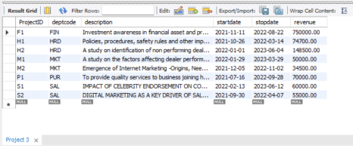

**Workson**

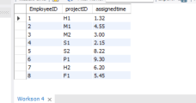

**Conclusion:**

**SQL database are the most prominent database, in which data can be inserted in form of tables with the help of some commands. Through these commands, one can create tables, and in each table, one can declare some entities . we can have entities named Primary keys which are used to identify the rows/tuples uniquely and foreign keys which are used to relate two different tables.**